Bash Scripting Tasks

1 Create a Basic Script with name hello world  
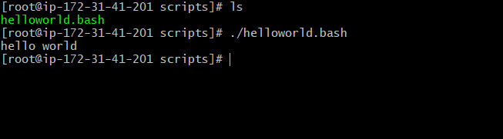

2. Create a script with 5 Linux Commands  
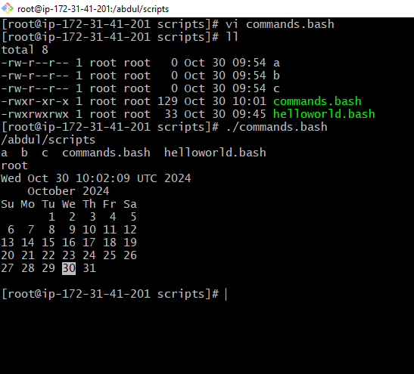

3. Linux admin commands top command

(Top | head -10)  
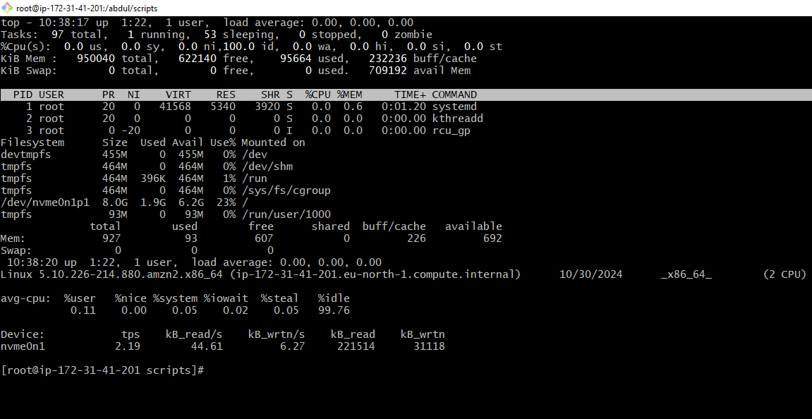

4. Defined variables  
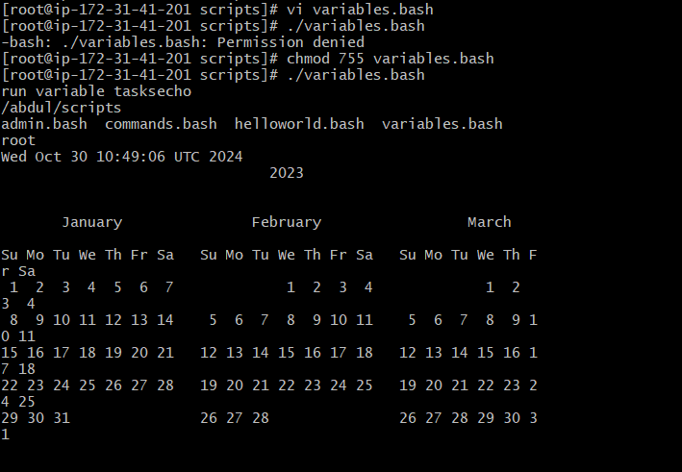

5. Input scripts  
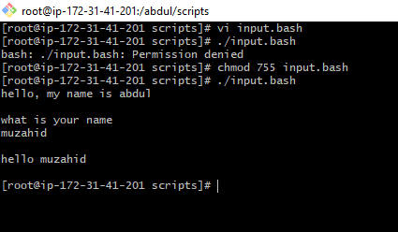

Output  
